Project Development Phase SPRINT-3

|  |  |
| --- | --- |
| Date | 8 November 2022 |
| Team ID | PNT2022TMID01761 |
| Project Name | Project - IOT Based Safety Gadget for Child Safety Monitoring&Notification |

NODE RED-Cloudant DB Communication: Step 1:Connections

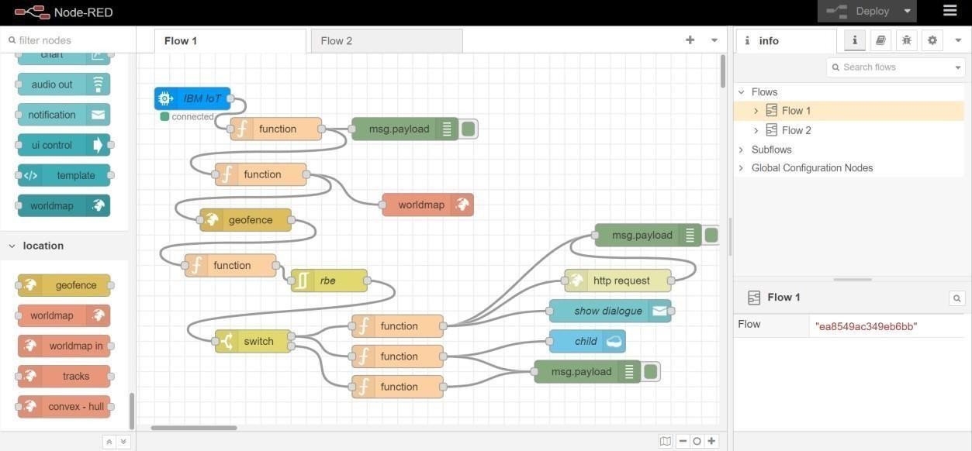

Step 2: Code in nodes

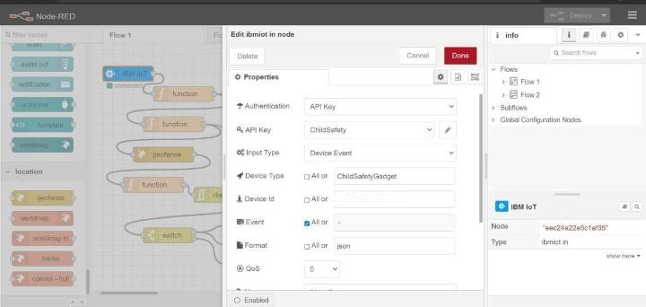

Step 3:Edit function mode(code)

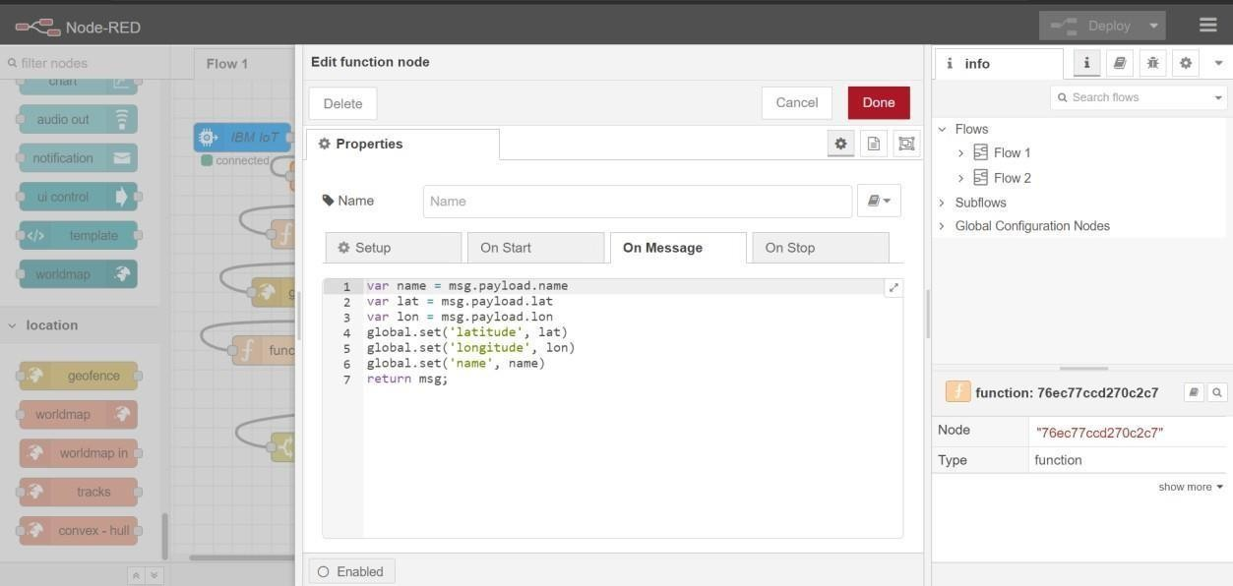

Step 4:

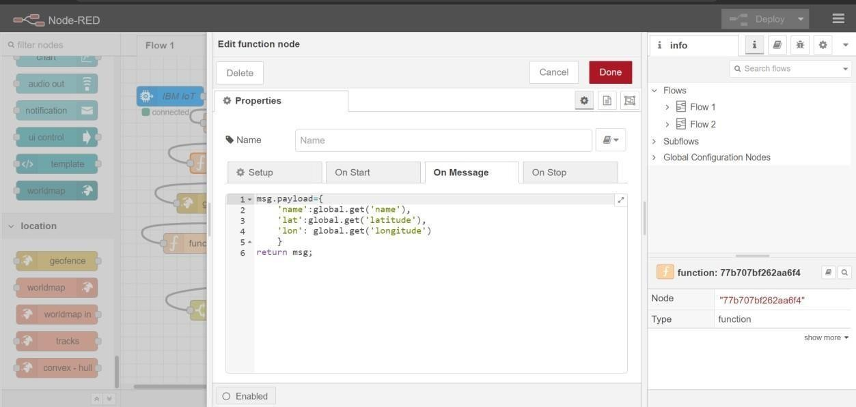

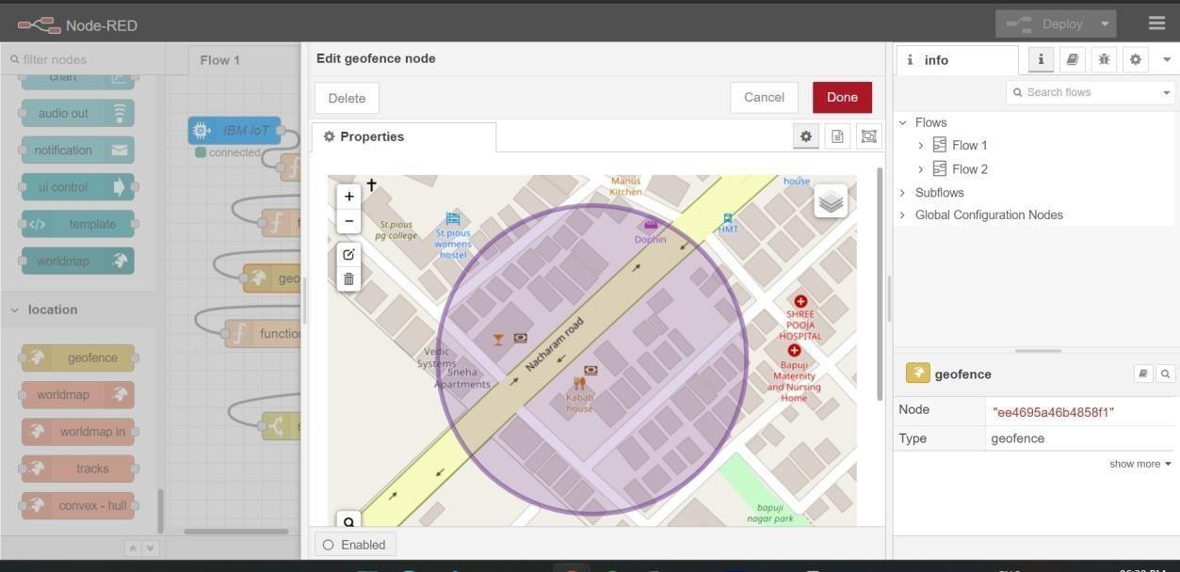

Step 6: Worldmap node with properties

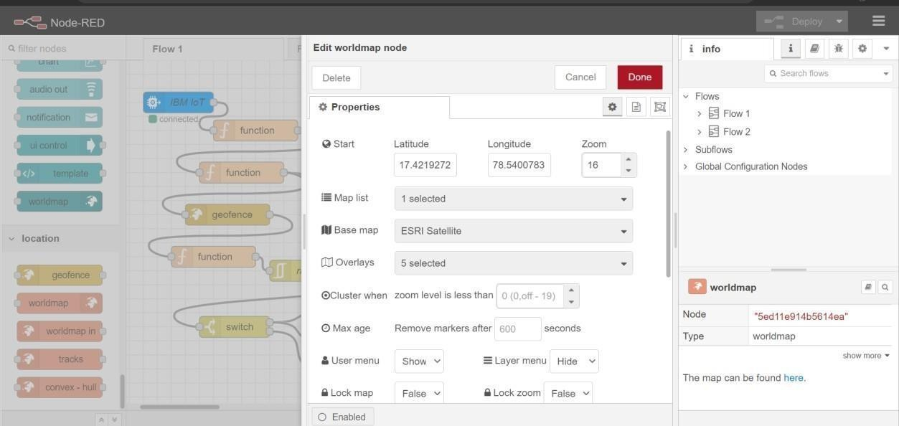

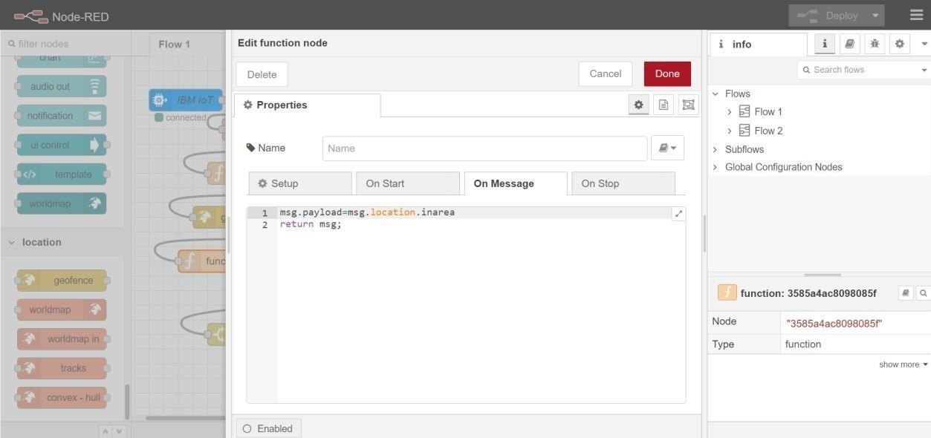

Step 8:Code with different node

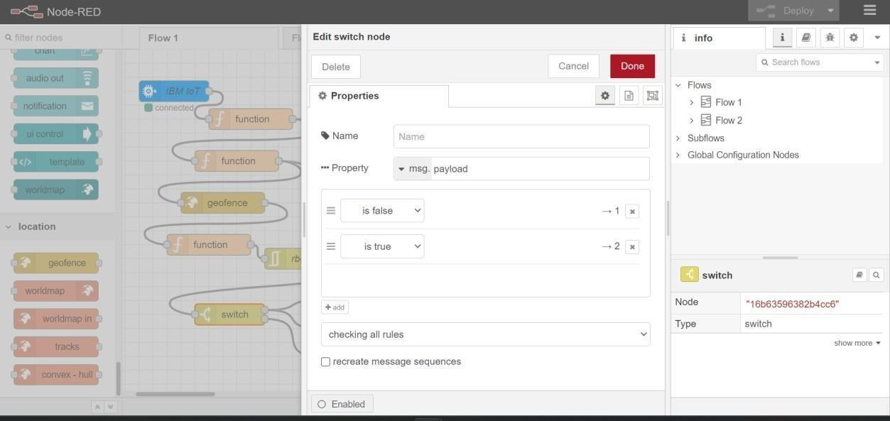

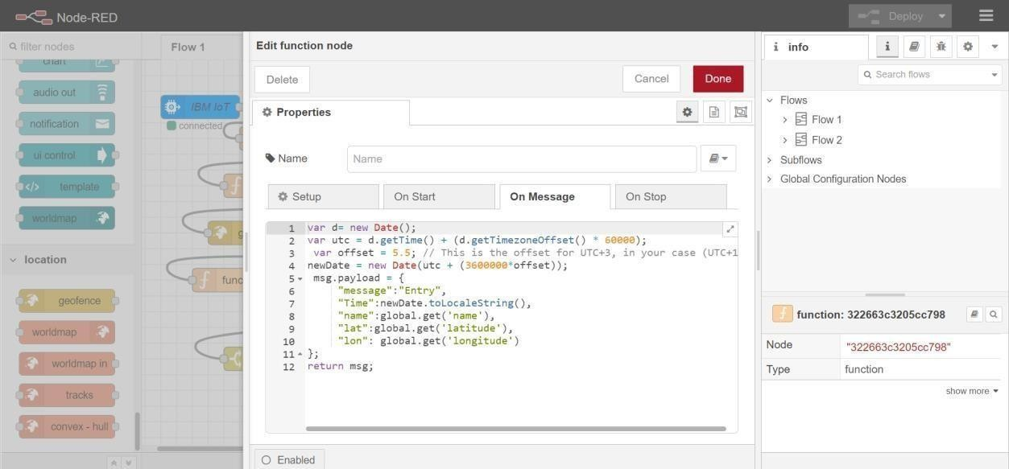

Step 10:code with different node

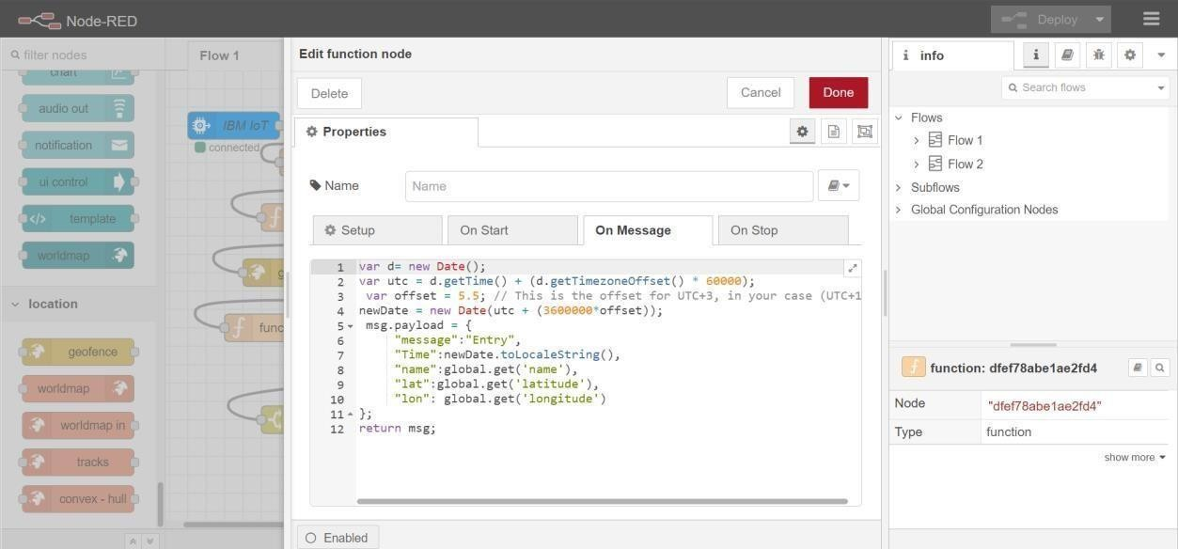

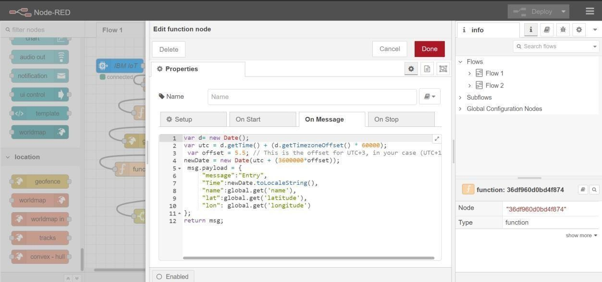

Step 12:Http request node->properties

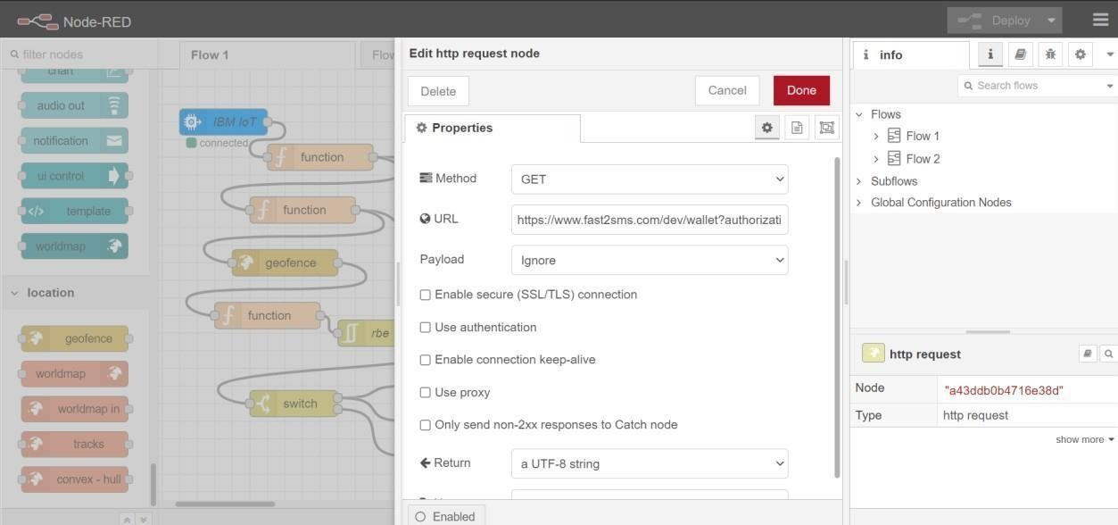

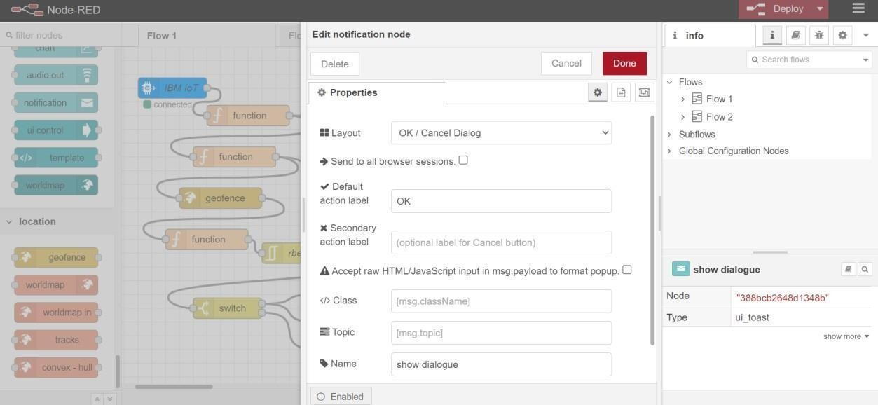

Step 14:Cloudant node

